AI BLOGNEST
Project Testing Phase
Date | 25/09/2026
Team ID | SWTID-2026-5382
Project Name | AI BlogNest

Team Leader : MONIKA K / Team Members : THIRISHA L, PARAMESWARI S, GOPALAKRISHNAN N
PHASE 6: PROJECT TESTING PHASE
Testing tools: Postman or the ThunderClient VS Code extension. Start the backend server with: npm start
6.1 User Registration
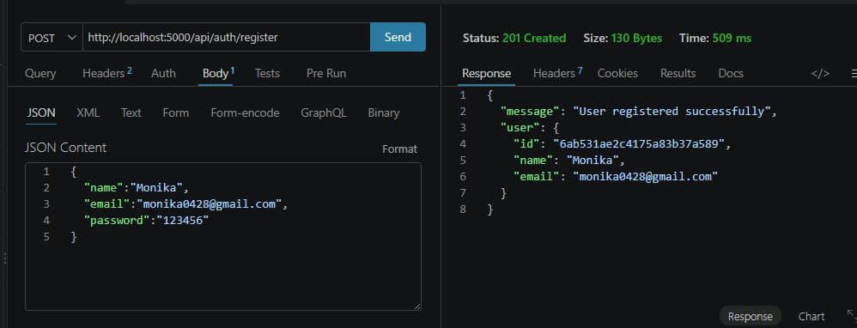
Fig 6.1 — User registration test
6.2 User Login
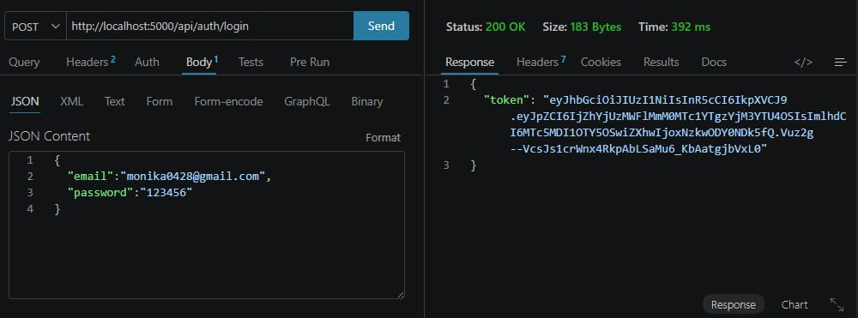
Fig 6.2 — User login test

6.3 Create Blogs
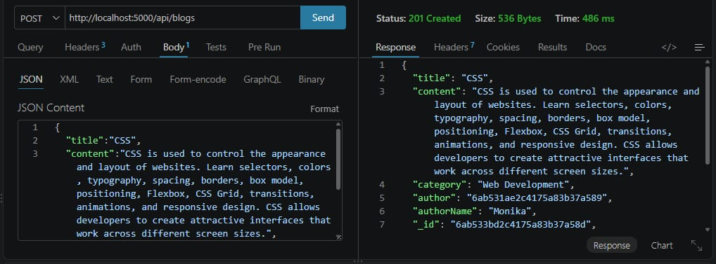
Fig 6.3 — Create blog test
6.4 Fetch Blogs
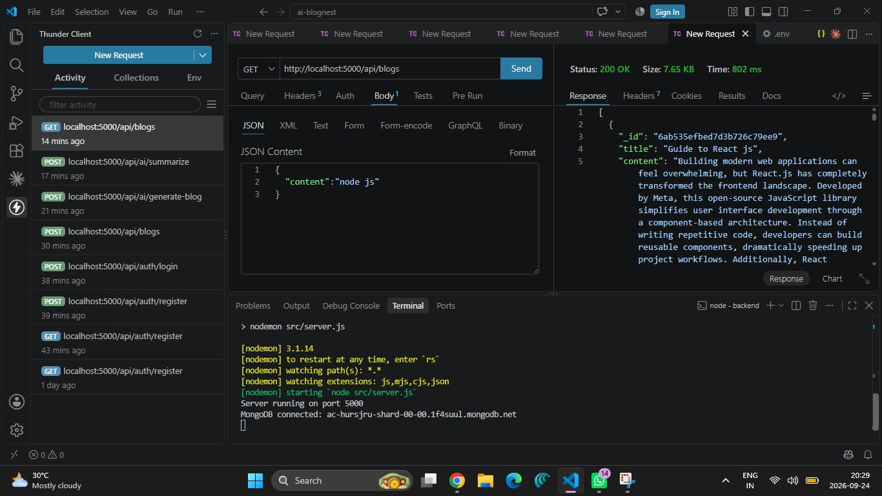
Fig 6.4 — Fetch blogs test

6.5 Generate AI Blogs
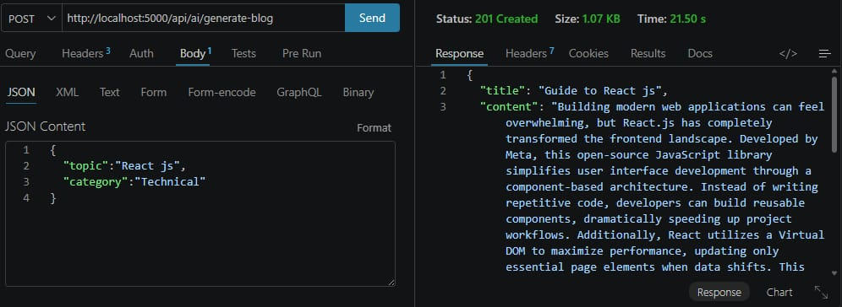
Fig 6.5 — AI blog generation test
6.6 Summarize Blogs
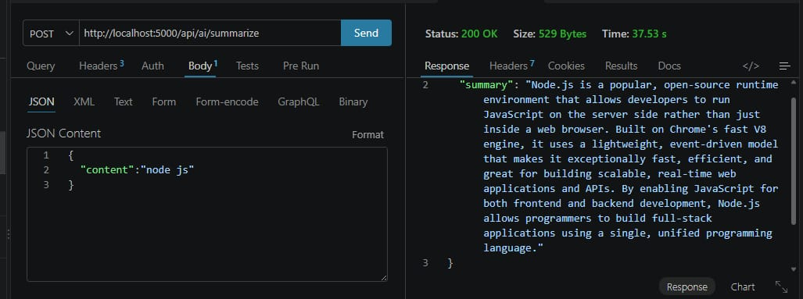
Fig 6.6 — AI summarization test

